For Immediate Release
Beta Glass Champions Breast Cancer Awareness through #FromGreenToPink Campaign
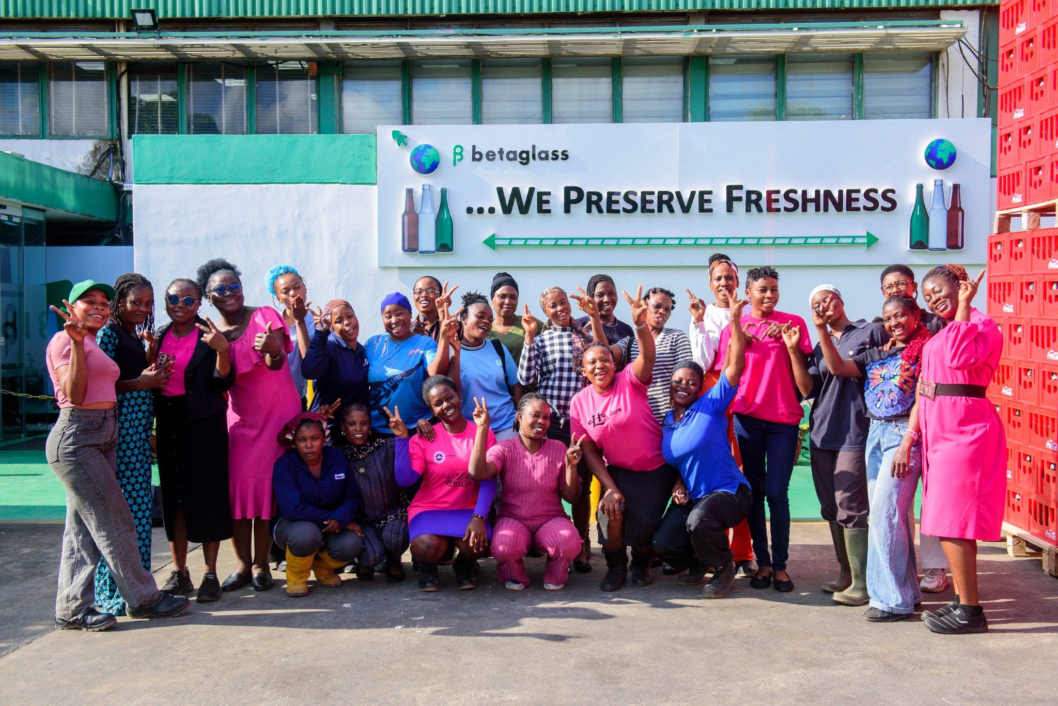
Caption: A cross section of Beta Glass employees at the company’s Agbara Plant, Ogun State, following the #FromGreenToPink breast cancer screening exercise held on Wednesday, 14 October 2026.
LAGOS, NIGERIA — 28th October 2026 — Beta Glass Plc, the largest glass container manufacturer in West and Central Africa, has reinforced its commitment to employee health and wellbeing through the 2026 edition of its #FromGreenToPink campaign. Launched in 2025, #FromGreenToPink is the company’s breast cancer campaign that focuses on women’s health and the importance of good environmental and sustainability practices.
Held in commemoration of Breast Cancer Awareness Month, popularly known as Pinktober, the initiative focused on an important aspect of preventive healthcare: ensuring that people have access to credible information about breast cancer and are encouraged to take appropriate steps towards early detection. This year's campaign featured an employee sensitisation session, breast cancer screenings across three Beta Glass locations and an awareness walk in Lagos.
The campaign commenced with a virtual breast cancer awareness session on 12 October 2026, during which healthcare professionals educated employees on breast cancer risk factors, potential warning signs, the importance of regular screening and the need to seek timely medical advice. The interactive session also provided an opportunity for employees to ask questions, address common misconceptions and gain practical information to support proactive healthcare.
Building on the awareness session, Beta Glass, in collaboration with its Health Maintenance Organisation (HMO) partner, conducted breast cancer screening exercises on 14 October 2026 at its headquarters in Victoria Island, Lagos, and its manufacturing plants in Agbara, Ogun State, and Ughelli, Delta State. By providing screening services at its facilities, the company sought to make preventive healthcare more accessible and encourage employees to translate awareness into action.
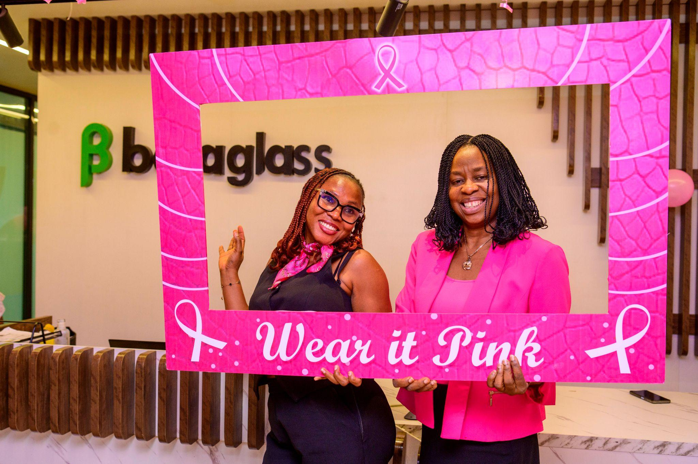
Caption: From L-R: Ufuoma Edeki, Administration Manager, Beta Glass Head Office, and Gladys Umoh, HR Director, Glass Division, Beta Glass Plc, during the #FromGreenToPink breast cancer screening exercise held on Wednesday, 14 October 2026, at the company’s Head Office, Victoria Island, Lagos.
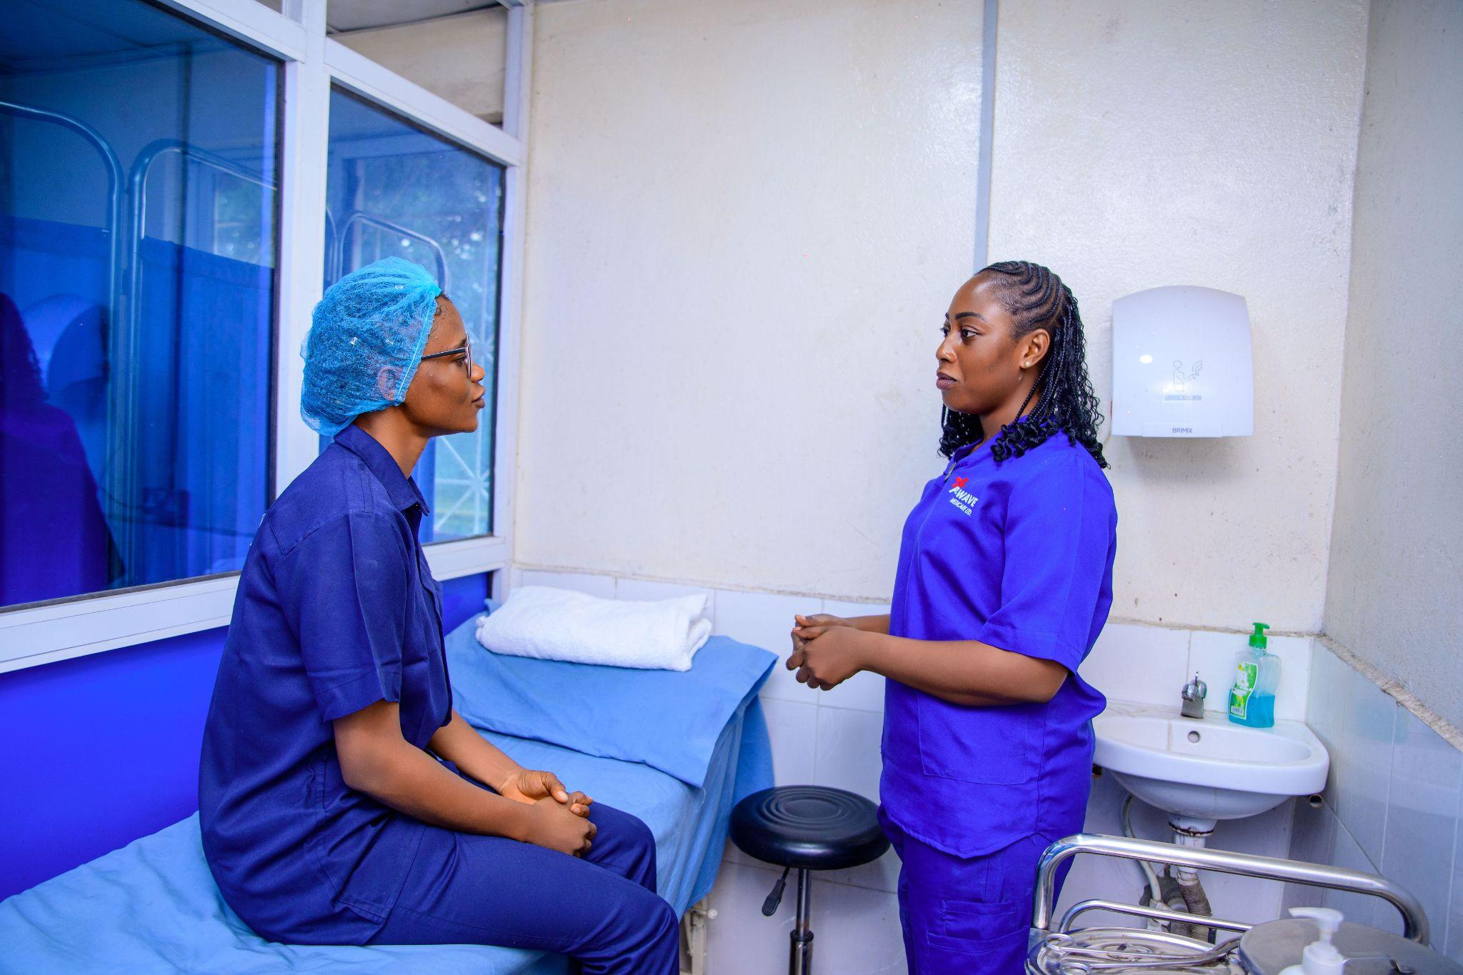
Caption: A Beta Glass employee with an HMO representative during the #FromGreenToPink breast cancer screening exercise held on Wednesday, 14 October 2026, at the company’s Ughelli Plant, Delta State.
Sharing her experience of the screening exercise, Diseye Famita Goni, Quality Assurance Specialist at Beta Glass' Ughelli Plant in Delta State, said: “I was very happy because I had never had this experience before. I had never been anywhere that provided free access to breast cancer screening.”
Extending the campaign beyond the workplace, Beta Glass employees also participated in a breast cancer awareness walk on 28 October 2026, from the company's Lagos Head Office in Victoria Island to Sandfill Bustop. Carrying branded campaign materials and awareness messages along the route, employees encouraged conversations about breast cancer, the importance of early detection and the need for regular screening and timely medical attention.

Caption: A cross section of Beta Glass employees holding breast cancer awareness placards during the #FromGreenToPink Breast Cancer Awareness Walk held on Wednesday, 28 October 2026, from the company’s Head Office, Victoria Island, Lagos, to Sandfill Bus Stop.
Also joining the awareness walk were representatives of Eti-Osa Local Government Area (LGA). Speaking on the campaign, Taiwo Olaitan, Health Education and Information Officer, Eti-Osa LGA, commended Beta Glass for promoting breast cancer awareness and preventive healthcare.
“Early detection of breast cancer is very important, especially as women grow older. We thank Beta Glass for organising this awareness walk. It has been a wonderful experience, and the campaign carries an important message. We look forward to more partnerships and collaborations with Beta Glass and more meaningful initiatives that will continue to raise awareness and promote the health and wellbeing of people in our communities.”
Commenting on the campaign, Gladys Umoh, HR Director, Beta Glass Plc, said: “Awareness is most valuable when people feel equipped and encouraged to act on what they have learnt. Through #FromGreenToPink, we are creating opportunities for our employees to access reliable health information and screening services within a supportive environment. We want our people to understand the importance of early detection and feel empowered to make informed decisions about their health.”
The 2026 edition of #FromGreenToPink builds on Beta Glass' ongoing efforts to promote employee health and wellbeing. By combining medical education, access to screening services and public awareness activities, the company continues to encourage proactive healthcare practices among its employees while extending important health messages to the wider community.
As Breast Cancer Awareness Month draws to a close, Beta Glass reiterates the campaign's central message, “Early Detection Saves Lives,” encouraging individuals to remain informed, prioritise appropriate screening and seek timely medical advice beyond October.

About Beta Glass Plc
Beta Glass Plc is a leading manufacturer of quality glass packaging solutions for the beverage, pharmaceutical, and food industries in West and Central Africa. The company is committed to innovation, sustainability, and delivering high-performance packaging solutions that support product integrity while promoting environmental responsibility.
Media Contact:
Prdesk@minc.ng
M.Inc Public Relations

